## Combinatorial Testing ( Cont’d… )

* Determines the combinations of configurations to be tested
* Identifies bugs related to incorrect handling of combinations and discovery of combinations that interact when they should not
* Complex systems and environments results in hundreds and thousands for combinatorial
* For Example: for client/server system
  + Operating system and service packs on client and server side
  + Database version, browser version o Multiple versions and configurations supported for different clients o Testing for multiple combinations of input parameter combinations

## Combinatorial Testing ( Cont’d… )

• Example 1: Configuration Possibilities

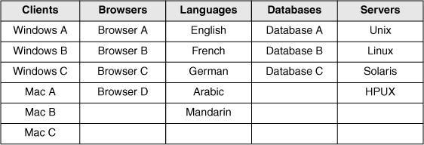

## Combinatorial Testing ( Cont’d… )

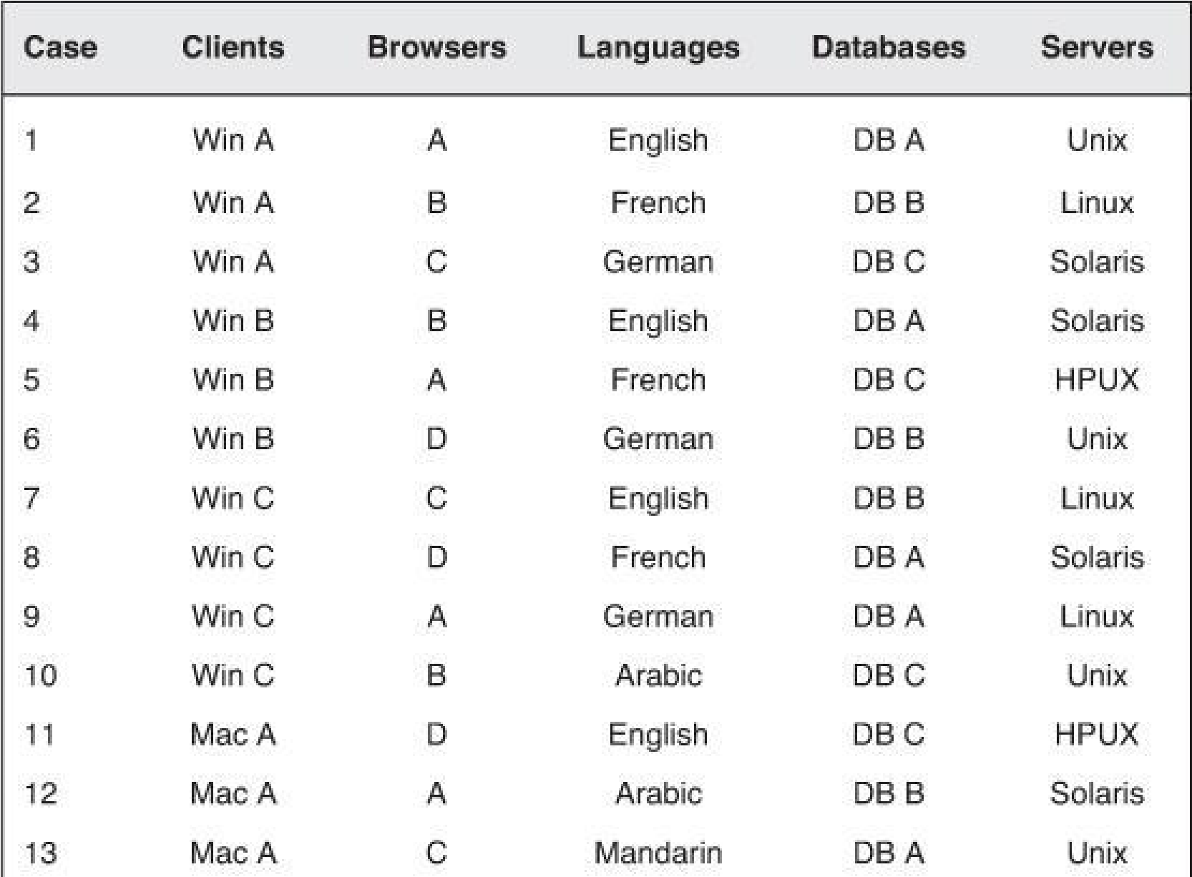• Example 1: All-pair testing (31 test cases instead of 1440)

